Supply Chain Performance Analysis Report
End to End Order Fulfillment Analysis & Predictive Insight
Name: Manika Rajput

Table of Contents
- Executive Summary
- Business Context & Objectives
- Key Performance Indicators (KPIs)
- Profitability Analysis
  - 4.1 Profitability Distribution
  - 4.2 Delay Distribution & Profit vs. Delay Days
- Bottleneck Detection
- Root Cause Analysis
- Time-Based Delay Patterns
- Machine Learning Model Results
- Strategic Recommendations
- Conclusion

1. Executive Summary
This report presents a detailed analysis of delivery operations for a global e-commerce company handling end-to-end order fulfillment across multiple international regions. The analysis includes 172,765 orders collected between January 2015 and January 2018. The main purpose of this study was to identify the major causes of late deliveries, measure their impact on business performance and profitability, and build a data-driven solution to improve delivery operations.
The analysis revealed a serious operational issue across the company. More than half of all customer orders were delivered late. The overall late delivery rate reached 54.71%, while only 45.29% of orders were delivered on time. This means delayed deliveries are not isolated incidents but a common customer experience across the business.
Even though the company generated around $7.5 million in total profit from fulfilled orders, approximately $2.1 million of profit is currently at risk because of delayed shipments and operational inefficiencies. The findings show that delivery delays are directly affecting customer satisfaction, operational reliability, and business profitability.
To help solve this issue, a machine learning prediction model was developed to identify orders that are likely to be delivered late before shipment occurs. A Random Forest Classifier was trained using historical order data and achieved an overall prediction accuracy of 74%. The model also achieved strong precision in identifying late orders, showing that it can be used as an effective operational alert system for proactive decision-making.

2. Business Context & Objectives
The company operates a global e-commerce platform selling products across different categories such as sporting goods, outdoor equipment, fitness products, footwear, and apparel. Since customers are spread across many international regions, delivery reliability is extremely important for maintaining customer trust and business performance.
Core Business Problem
The company frequently fails to deliver orders within the promised delivery window. Actual shipping times often differ from scheduled delivery commitments, creating customer dissatisfaction and reducing operational efficiency. These delays also increase pressure on logistics systems and reduce profitability.
Because customers expect reliable delivery timelines during checkout, repeated delivery failures can damage customer trust and negatively impact future business growth.
Analytical Objectives
The analysis was designed to achieve the following business objectives:
- Understand the current state of delivery performance across all operational dimensions
- Measure the financial impact caused by delayed deliveries
- Identify the main operational bottlenecks creating delays
- Build a predictive model to identify high-risk orders before shipment
- Provide practical recommendations to improve on-time delivery performance and profitability

3. Operational Performance Overview
Metric | Value
Total Orders Analyzed | 172,765
Late Deliveries | 94,523
Late Delivery Rate | 54.71%
On-Time Delivery Rate | 45.29%
Total Profit | $7.5M
Profit at Risk | $2.1M
Average Delay | 3 Days
Average Profit per Order | $22.03
The operational analysis clearly shows that delayed delivery is a large-scale company-wide issue. More than half of all customer orders arrive late, making late delivery the default experience for many customers.
The financial impact is also significant. Even though the business remains profitable overall, delayed orders place a large amount of profit at risk and create long-term customer experience problems.

4. Profitability Analysis

4.1 Profitability Distribution
Order profitability was divided into categories using profit earned per order. Most orders remain profitable, but a noticeable portion of orders generate losses.
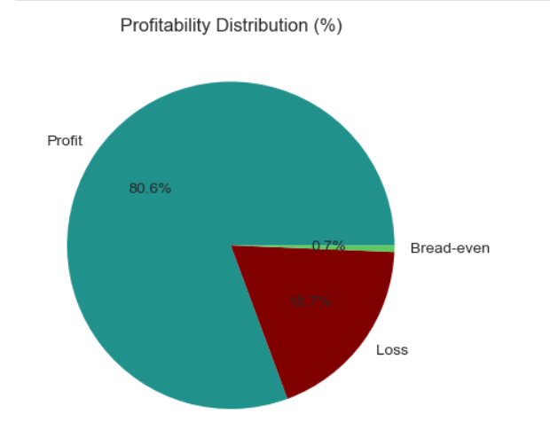
Fig:1
Profitability Category | Percentage
Profitable Orders | 80.7%
Loss-Making Orders | 18.7%
One important finding from the analysis is that average profit per order stays fairly stable across different delay levels. Most delayed and non-delayed orders generate approximately $21 to $23 profit per order.
This means the profitability issue is mainly caused by the large number of delayed orders, not because delayed orders individually generate lower profits.
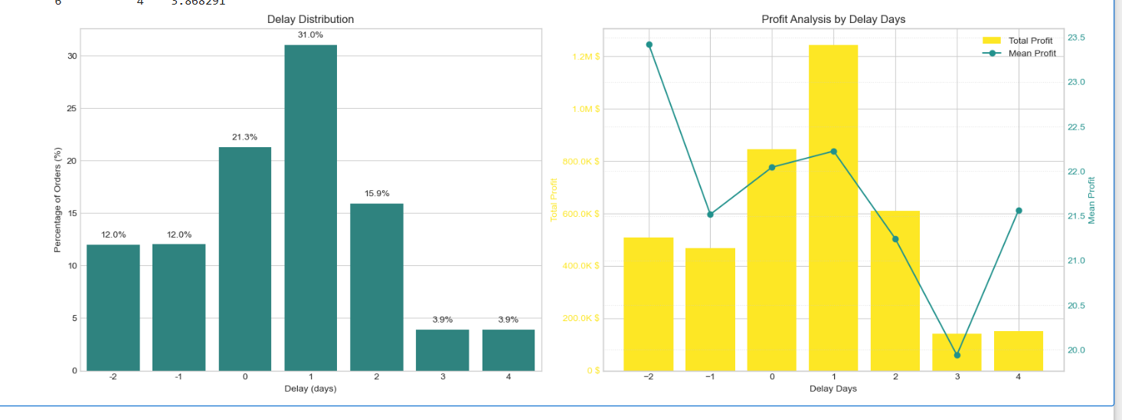
Fig:2
As a result, improving overall delivery efficiency and reducing the total number of delayed shipments would create the biggest positive business impact.

5. Bottleneck Detection
Delivery delay percentages were analysed across several operational areas to identify where the fulfillment process is failing most often.
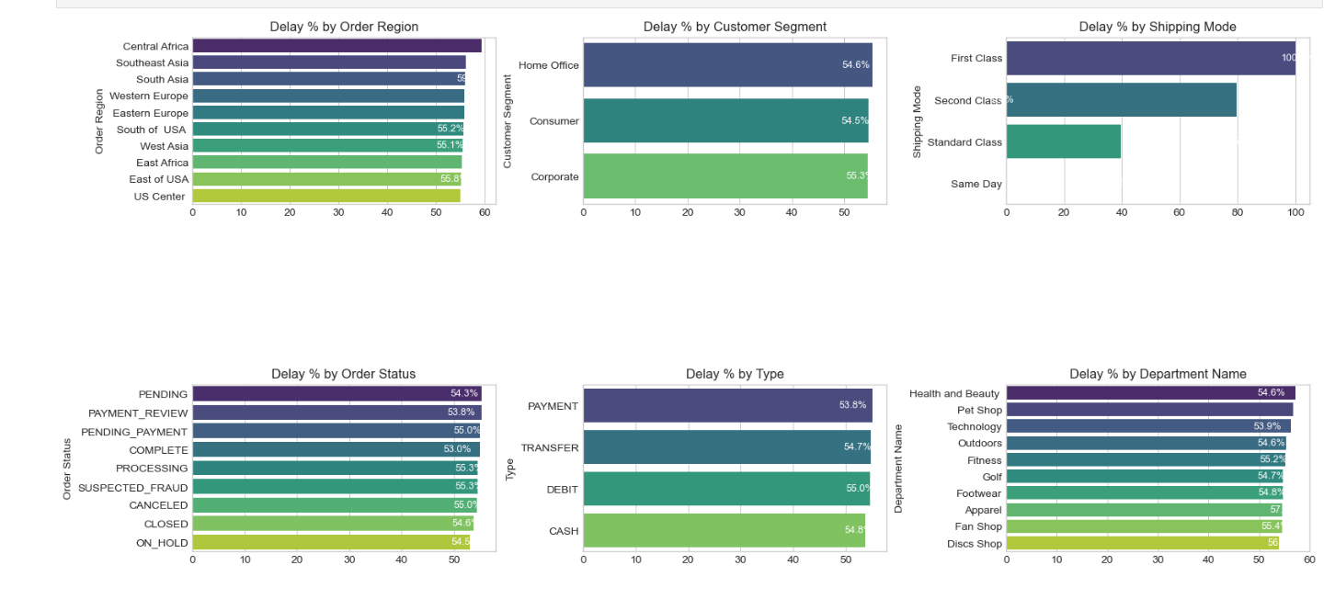
Key Operational Findings
Key Insight | Detailed Observation
Shipping Mode is the Biggest Problem | First Class shipping showed a 100% delay rate, while Second Class reached 79.8%. Standard Class performed much better at 39.8%, and Same Day shipping had no delays.
Regional Delay Rates are Similar | All regions showed delay rates between 55% and 59%, which proves the issue is company-wide rather than limited to one location.
Customer Segments Perform Similarly | Consumer, Corporate, and Home Office customers all experienced similar delay percentages.
Certain Departments Have Higher Delays | Health & Beauty and Pet Shop departments showed slightly higher delay rates than other departments.
Delivery Performance Insights
- The overall late delivery rate reached 54.71%
- Delayed orders placed approximately $2.1M of profit at risk
- The 90th percentile delay remained within 3 days, showing that delays are operational and process-related rather than catastrophic failures
These findings show that the company’s delivery problems are mainly caused by operational inefficiencies and poor shipping management decisions.

6. Root Cause Analysis
A detailed root cause analysis was performed for Central Africa, which recorded the highest delay rate at 58.7%.
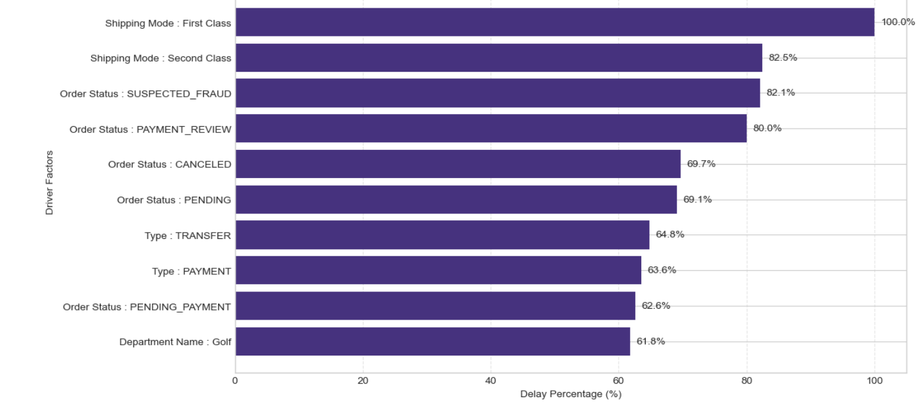
The analysis identified several major operational drivers contributing to delays:
- Poor performance of premium shipping modes
- Delays in payment review and payment approval processes
- High-delay product departments such as Outdoors and Golf
- Operational bottlenecks during fulfillment and shipping coordination
The findings show that shipping mode assignment and payment processing are two of the most important operational problems affecting delivery performance.

7. Time-Based Delay Patterns
Delivery delays were also analysed across three-time dimensions:
- Month of the year
- Day of the week
- Hour of the day

Key Findings
Observation | Detailed Insight
Peak Delay Months | August, September, and December showed the highest delay percentages because of seasonal demand increases and holiday order surges.
Day-of-Week Differences are Small | Delay percentages remained similar across all weekdays, showing that day-of-week is not a major operational factor.
Hourly Delay Peaks Exist | Orders placed during late evening hours and midday periods experienced slightly higher delay rates because of processing bottlenecks and operational cutoff times.
The results show that seasonal demand patterns are predictable and can be managed better with stronger capacity planning and logistics preparation.

8. Machine Learning Model Results
A supervised machine learning model was created to predict whether an order would be delivered late (Late_delivery_risk = 1).
The prediction pipeline included:
- Frequency encoding for categorical variables
- Stratified train-test splitting
- SMOTE oversampling to balance the dataset
- Random Forest classification
Class Imbalance Handling
Training Data | On-Time Orders | Late Orders
Before SMOTE | 59,030 | 79,182
After SMOTE | 79,182 | 79,182
Random Forest Model Performance
Metric | Class 0 (On-Time) | Class 1 (Late) | Weighted Average
Precision | 0.68 | 0.78 | 0.74
Recall | 0.72 | 0.75 | 0.74
F1-Score | 0.70 | 0.77 | 0.74
Accuracy | — | — | 74%
Important Model Insights
- The model correctly predicts almost three out of four orders
- Precision for late-order prediction reached 78%
- The model performs well enough for real operational use
This prediction system can help the company identify risky orders early and take preventive action before delays happen.

9. Strategic Recommendations
1. Audit First Class and Second-Class Shipping
Priority: Critical
First Class and Second-Class shipping are performing very poorly compared to customer expectations. Immediate review of carrier agreements and operational workflows is necessary.
2. Deploy the Predictive Alert System
Priority: High
The Random Forest model should be integrated into the company’s order management system to identify risky orders and trigger proactive operational actions.
3. Improve Payment Processing
Priority: High
Orders stuck in payment review or pending payment stages should be automatically escalated to reduce unnecessary shipping delays.
4. Prepare for Seasonal Demand Surges
Priority: Medium
The company should create seasonal logistics plans for peak periods such as August, September, and December.
5. Increase Use of Standard Class Shipping
Priority: Medium
Standard Class shipping performs much better than premium shipping modes and should be used more frequently for eligible orders.
6. Investigate High-Delay Departments
Priority: Medium
Departments such as Outdoors and Golf should undergo operational audits to identify inventory or fulfillment problems.
7. Reduce Loss-Making Orders
Priority: Low
The company should review pricing and discount strategies to reduce the percentage of orders generating losses.

10. Conclusion
This analysis highlights a major operational challenge within the company’s global e-commerce fulfillment system. More than half of all customer orders fail to arrive on time, creating significant financial risk and damaging customer trust.
The analysis shows that the problem is mainly caused by operational inefficiencies rather than isolated regional failures. Poor shipping mode performance, payment processing delays, and weak preparation for seasonal demand surges are the main drivers behind delayed deliveries.
Most importantly, the findings prove that these problems can be measured, predicted, and improved. The Random Forest prediction model already achieves 74% accuracy in identifying risky orders before shipment, making it a practical solution for operational decision-making.
By implementing the recommended operational improvements and predictive systems, the company can significantly reduce delays, improve profitability, and deliver a better customer experience across all regions.

Strategic Performance Roadmap
Priority Area | Current State | Target State
Late Delivery Rate | 54.71% | < 30% within 12 months
First Class On-Time Rate | 0% | > 80%
Second Class On-Time Rate | 20.2% | > 60%
Predictive Model Accuracy | 74% | > 82%
Loss-Making Orders | 18.7% | < 12%
Profit at Risk | $2.1M | Reduce by 40%

